**REACT 03**

**AIM:**

Create a react app for Student Management Portal named scorecalculatorapp and create a function component named “CalculateScore” which will accept Name, School, Total and goal in order to calculate the average score of a student and display the same.

**PROGRAM:**

**CalculateScore.js:**

import React, { useState } from 'react';

import '../Stylesheets/mystyle.css';

function CalculateScore() {

  const [name, setName] = useState('');

  const [school, setSchool] = useState('');

  const [total, setTotal] = useState('');

  const [goal, setGoal] = useState('');

  const [average, setAverage] = useState(null);

  const handleSubmit = (e) => {

    e.preventDefault();

    const avg = parseFloat(total) / parseFloat(goal);

    setAverage(avg.toFixed(2));

  };

  const feedbackClass = average >= 75 ? 'high' : average >= 50 ? 'medium' : 'low';

  return (

    <div className="card">

      <h2>🎓 Score Calculator</h2>

      <form onSubmit={handleSubmit}>

        <input

          type="text"

          placeholder="Student Name"

          value={name}

          onChange={(e) => setName(e.target.value)}

          required

        />

        <input

          type="text"

          placeholder="School Name"

          value={school}

          onChange={(e) => setSchool(e.target.value)}

          required

        />

        <input

          type="number"

          placeholder="Total Marks"

          value={total}

          onChange={(e) => setTotal(e.target.value)}

          required

        />

        <input

          type="number"

          placeholder="Goal (Max Marks)"

          value={goal}

          onChange={(e) => setGoal(e.target.value)}

          required

        />

        <button type="submit">Calculate</button>

      </form>

      {average && (

        <div className={`result ${feedbackClass}`}>

          <p><strong>Name:</strong> {name}</p>

          <p><strong>School:</strong> {school}</p>

          <p><strong>Average Score:</strong> {average}</p>

        </div>

      )}

    </div>

  );

}

export default CalculateScore;

**mystyle.css:**

body {

  margin: 0;

  padding: 0;

  background: linear-gradient(to right, #6a11cb, #2575fc);

  font-family: 'Segoe UI', sans-serif;

}

.card {

  background: white;

  padding: 30px;

  max-width: 500px;

  margin: 50px auto;

  border-radius: 16px;

  box-shadow: 0 4px 12px rgba(0, 0, 0, 0.2);

  text-align: center;

}

input {

  display: block;

  margin: 15px auto;

  padding: 10px;

  width: 80%;

  border: 1px solid #ccc;

  border-radius: 6px;

  font-size: 16px;

}

button {

  padding: 10px 20px;

  background-color: #2575fc;

  color: white;

  border: none;

  font-size: 16px;

  border-radius: 6px;

  cursor: pointer;

  transition: 0.3s;

}

button:hover {

  background-color: #1a5dd0;

}

.result {

  margin-top: 25px;

  padding: 20px;

  border-radius: 12px;

  font-size: 1.1rem;

}

.result.high {

  background-color: #d4edda;

  color: #155724;

}

.result.medium {

  background-color: #fff3cd;

  color: #856404;

}

.result.low {

  background-color: #f8d7da;

  color: #721c24;

}

**INDEX.js:**

import React from 'react';

import ReactDOM from 'react-dom/client';

import './index.css';

import App from './App';

import reportWebVitals from './reportWebVitals';

const root = ReactDOM.createRoot(document.getElementById('root'));

root.render(

  <React.StrictMode>

    <App />

  </React.StrictMode>

);

reportWebVitals();

**APP.js:**

import React from 'react';

import './App.css';

import CalculateScore from './Components/CalculateScore';

function App() {

  return (

    <div className="App">

      <CalculateScore />

    </div>

  );

}

export default App;

OUTPUT 01:

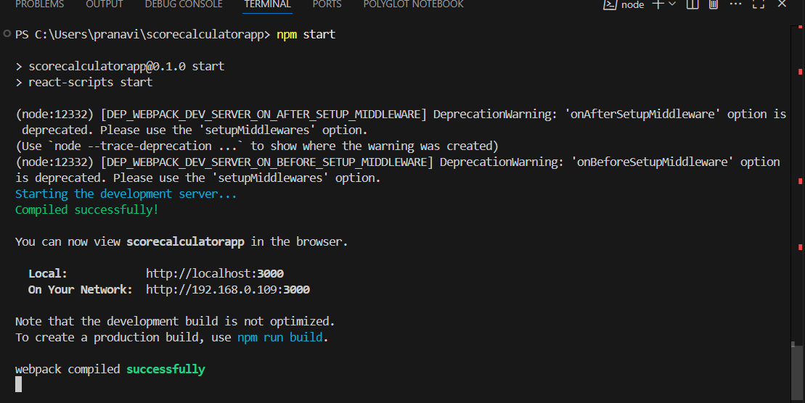

**OUTPUT 02:**

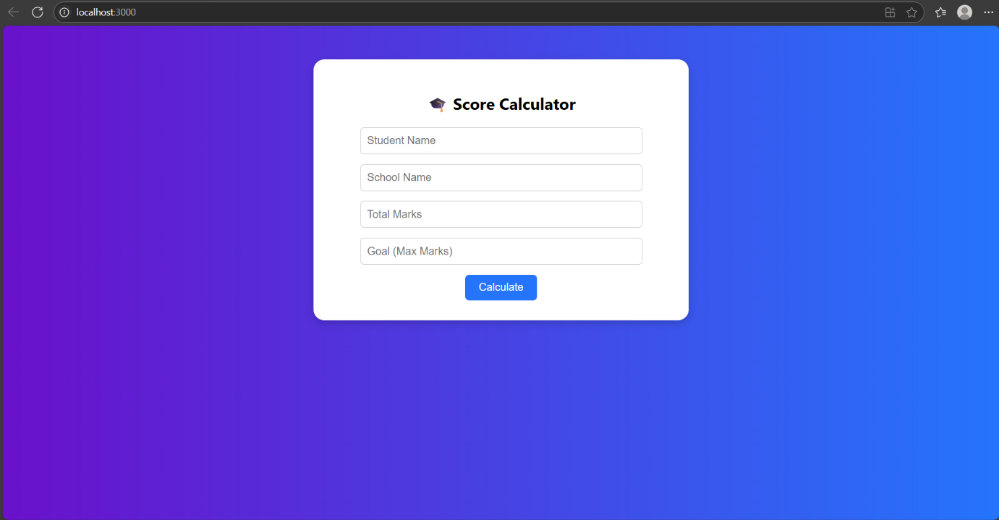

**OUTPUT 03:**

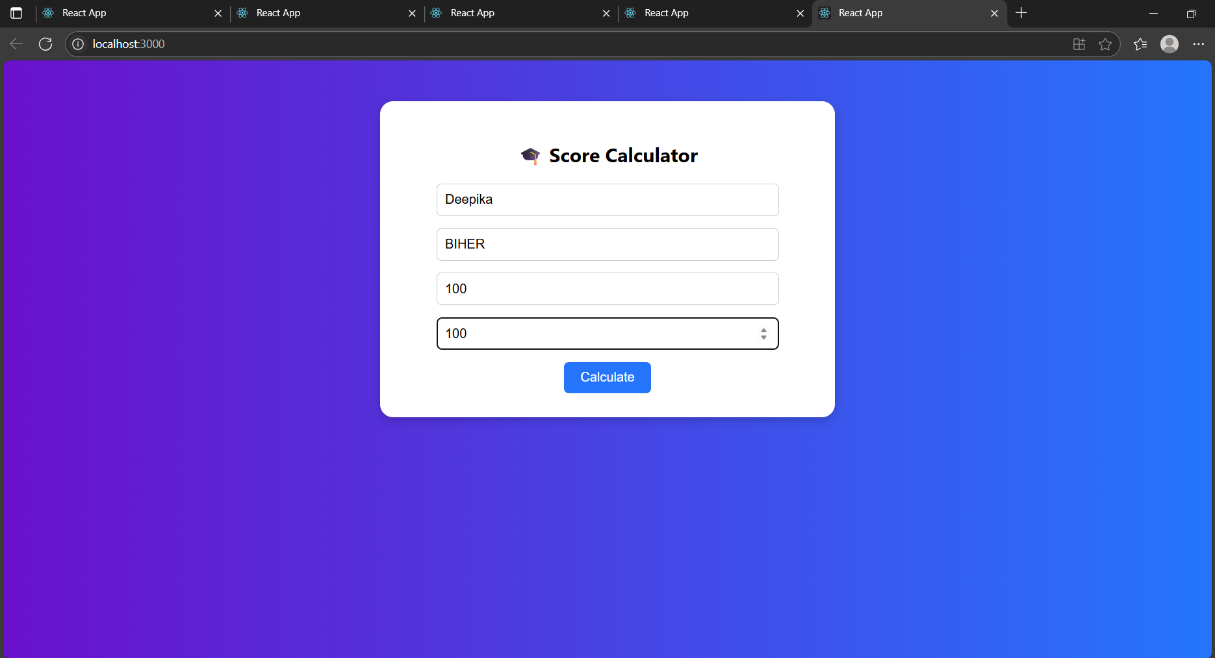

**OUTPUT 04:**

